Experiment: Autoencoders for Image Denoising

Aim
To explore and implement an Autoencoder model for removing noise from images and reconstructing clean images using deep learning techniques.

Theory
An Autoencoder is a type of Artificial Neural Network used for learning efficient representations of data (encoding) and reconstructing it (decoding).

Basic Structure
An autoencoder has three main parts:
- Encoder – Compresses input image into a smaller representation (latent space)
- Latent Space (Bottleneck) – Stores important features
- Decoder – Reconstructs image from compressed data

Denoising Autoencoder
A Denoising Autoencoder is trained to:
- Take a noisy image as input
- Output a clean image
It learns how to remove noise and preserve important features.

Working Principle
- Add noise to original images
- Feed noisy images to the model
- Model learns mapping:
Noisy Image → Clean Image
- Loss function calculates reconstruction error

Loss Function
Commonly used:
- Mean Squared Error (MSE)
It minimizes the difference between original and reconstructed images.

Applications
- Image denoising
- Image compression
- Medical imaging
- Feature extraction

Procedure
- Import required libraries (TensorFlow, Keras, NumPy)
- Load dataset (e.g., MNIST)
- Normalize image data
- Add noise to images
- Build Autoencoder model
- Compile the model
- Train the model
- Test model on noisy images
- Compare original vs noisy vs reconstructed images

Code (Python using TensorFlow/Keras)
import numpy as np
import matplotlib.pyplot as plt
from tensorflow.keras.datasets import mnist
from tensorflow.keras.layers import Input, Dense, Flatten, Reshape
from tensorflow.keras.models import Model

# Load dataset
(x_train, _), (x_test, _) = mnist.load_data()

# Normalize data
x_train = x_train / 255.0
x_test = x_test / 255.0

# Add noise
noise_factor = 0.5
x_train_noisy = x_train + noise_factor * np.random.normal(size=x_train.shape)
x_test_noisy = x_test + noise_factor * np.random.normal(size=x_test.shape)

# Clip values between 0 and 1
x_train_noisy = np.clip(x_train_noisy, 0., 1.)
x_test_noisy = np.clip(x_test_noisy, 0., 1.)

# Flatten images
x_train = x_train.reshape(-1, 784)
x_test = x_test.reshape(-1, 784)
x_train_noisy = x_train_noisy.reshape(-1, 784)
x_test_noisy = x_test_noisy.reshape(-1, 784)

# Build Autoencoder
input_img = Input(shape=(784,))

# Encoder
encoded = Dense(128, activation='relu')(input_img)
encoded = Dense(64, activation='relu')(encoded)

# Decoder
decoded = Dense(128, activation='relu')(encoded)
decoded = Dense(784, activation='sigmoid')(decoded)

# Model
autoencoder = Model(input_img, decoded)

# Compile model
autoencoder.compile(optimizer='adam', loss='mse')

# Train model
autoencoder.fit(x_train_noisy, x_train,
epochs=10,
batch_size=256,
shuffle=True,
validation_data=(x_test_noisy, x_test))

# Predict
decoded_imgs = autoencoder.predict(x_test_noisy)

# Display results
n = 5
plt.figure(figsize=(10, 4))
for i in range(n):
# Noisy image
ax = plt.subplot(3, n, i + 1)
plt.imshow(x_test_noisy[i].reshape(28, 28), cmap='gray')
plt.title("Noisy")
plt.axis('off')

# Original image
ax = plt.subplot(3, n, i + 1 + n)
plt.imshow(x_test[i].reshape(28, 28), cmap='gray')
plt.title("Original")
plt.axis('off')

# Reconstructed image
ax = plt.subplot(3, n, i + 1 + 2*n)
plt.imshow(decoded_imgs[i].reshape(28, 28), cmap='gray')
plt.title("Denoised")
plt.axis('off')

plt.show()

Output :
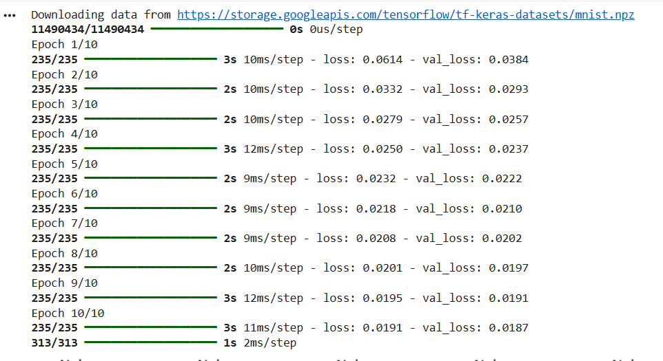

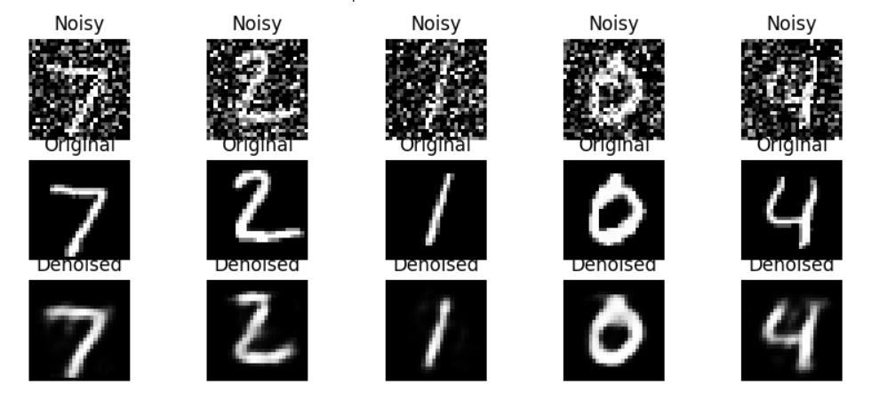

Conclusion
- The Autoencoder successfully learns to remove noise from images.
- It reconstructs clean images from noisy inputs.
- The model reduces reconstruction error using MSE loss.
- Denoising Autoencoders are useful in real-world applications like medical imaging and image restoration.

